Github https://github.com/k256534/PF-labs

Question 1
#include <stdio.h>

int main()
{
int marks[4][3];
int i,j;
int total;
float avg;

printf("Enter marks for 4 students and 3 subjects:\n");

for(i=0;i<4;i++)
{
printf("\nStudent %d:\n",i+1);

for(j=0;j<3;j++)
{
printf("Subject %d: ",j+1);
scanf("%d",&marks[i][j]);
}
}

printf("\nTotal marks of each student:\n");

for(i=0;i<4;i++)
{
total=0;

for(j=0;j<3;j++)
{
total = total + marks[i][j];
}

printf("Student %d Total = %d\n",i+1,total);
}

printf("\nAverage marks of each subject:\n");

for(j=0;j<3;j++)
{
total=0;

for(i=0;i<4;i++)
{
total = total + marks[i][j];
}

avg = (float)total/4;

printf("Subject %d Average = %.2f\n",j+1,avg);
}

return 0;
}

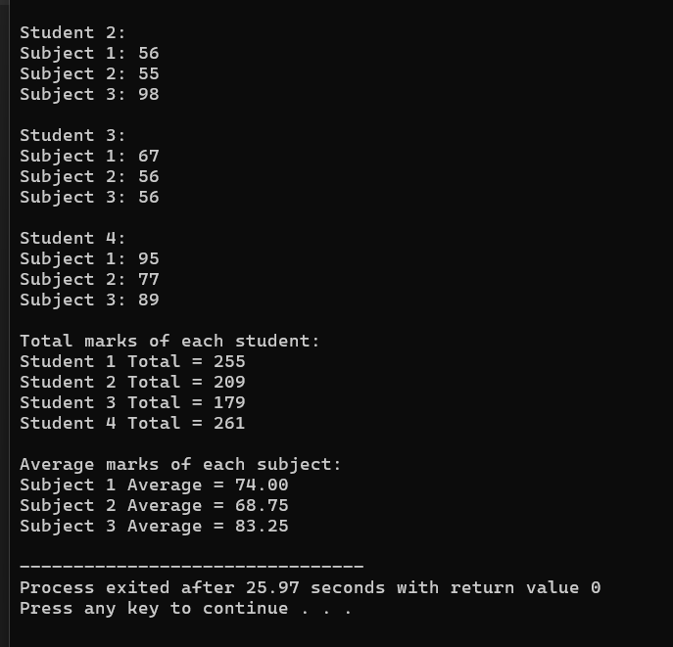

Question 2
#include <stdio.h>

int main()
{
int seats[5][6];
int i,j;
int available=0;
int booked;
int maxBooked=0;
int rowNo=0;

printf("Enter seat status (0=available, 1=booked):\n");

for(i=0;i<5;i++)
{
printf("\nRow %d\n",i+1);

for(j=0;j<6;j++)
{
scanf("%d",&seats[i][j]);
}
}

for(i=0;i<5;i++)
{
booked=0;

for(j=0;j<6;j++)
{
if(seats[i][j]==0)
available++;

if(seats[i][j]==1)
booked++;
}

if(booked > maxBooked)
{
maxBooked = booked;
rowNo = i+1;
}
}

printf("\nAvailable seats = %d\n",available);
printf("Row with maximum booked seats = %d\n",rowNo);

return 0;
}
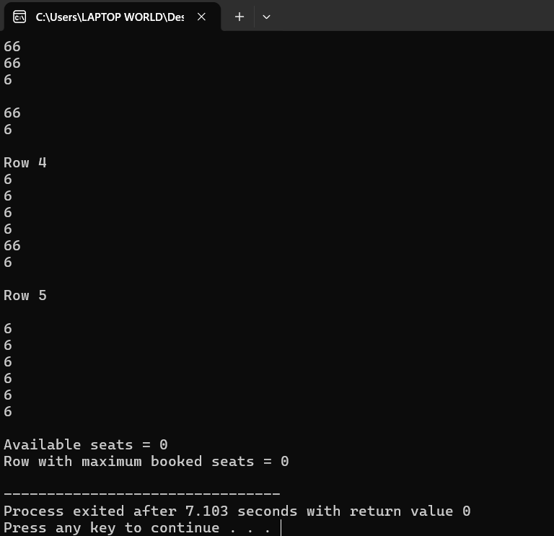

Question 3
#include <stdio.h>

int main()
{
int temp[7][3];
int i,j;
int max;
int sum;
float avg;

printf("Enter temperatures for 7 days (Morning Afternoon Night):\n");

for(i=0;i<7;i++)
{
printf("\nDay %d\n",i+1);

for(j=0;j<3;j++)
{
scanf("%d",&temp[i][j]);
}
}

max = temp[0][0];

for(i=0;i<7;i++)
{
for(j=0;j<3;j++)
{
if(temp[i][j] > max)
max = temp[i][j];
}
}

printf("\nHighest temperature in the week = %d\n",max);

printf("\nAverage temperature of each day:\n");

for(i=0;i<7;i++)
{
sum=0;

for(j=0;j<3;j++)
{
sum += temp[i][j];
}

avg = (float)sum/3;

printf("Day %d Average = %.2f\n",i+1,avg);
}

return 0;
}
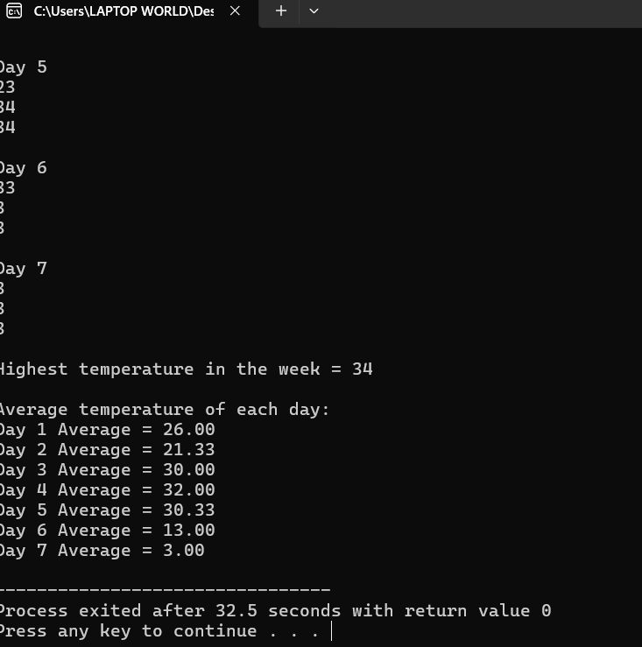

Quesrion 4
#include <stdio.h>

int main()
{
int a[3][3], t[3][3];
int i,j;
int det;

printf("Enter 3x3 matrix:\n");

for(i=0;i<3;i++)
{
for(j=0;j<3;j++)
{
scanf("%d",&a[i][j]);
}
}

printf("\nMatrix:\n");

for(i=0;i<3;i++)
{
for(j=0;j<3;j++)
{
printf("%d ",a[i][j]);
}
printf("\n");
}

printf("\nTranspose:\n");

for(i=0;i<3;i++)
{
for(j=0;j<3;j++)
{
printf("%d ",a[j][i]);
}
printf("\n");
}

det = a[0][0]*(a[1][1]*a[2][2]-a[1][2]*a[2][1])
- a[0][1]*(a[1][0]*a[2][2]-a[1][2]*a[2][0])
+ a[0][2]*(a[1][0]*a[2][1]-a[1][1]*a[2][0]);

printf("\nDeterminant = %d\n",det);

if(det==0)
printf("Inverse does not exist\n");
else
printf("Inverse exists\n");

return 0;
}
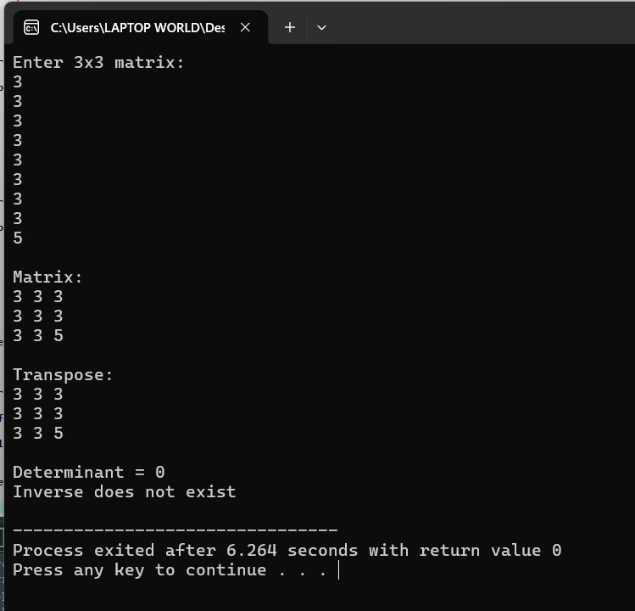

Question 5
#include <stdio.h>

int main()
{
int a[5][5];
int r,c,i,j;
int zero=1, identity=1;

printf("Enter rows and columns: ");
scanf("%d%d",&r,&c);

printf("Enter matrix:\n");

for(i=0;i<r;i++)
{
for(j=0;j<c;j++)
{
scanf("%d",&a[i][j]);
}
}

if(r==c)
printf("Square Matrix\n");
else
printf("Rectangular Matrix\n");

for(i=0;i<r;i++)
{
for(j=0;j<c;j++)
{
if(a[i][j]!=0)
zero=0;

if(i==j && a[i][j]!=1)
identity=0;

if(i!=j && a[i][j]!=0)
identity=0;
}
}

if(zero)
printf("Zero Matrix\n");

if(identity)
printf("Identity Matrix\n");

if(r==1)
printf("Row Matrix\n");

if(c==1)
printf("Column Matrix\n");

return 0;
}
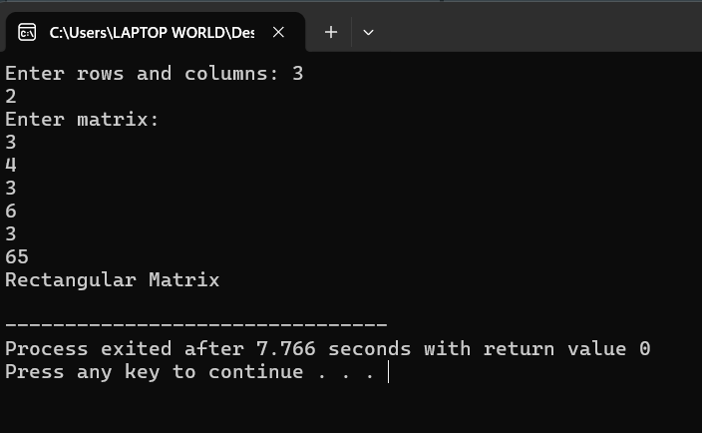

Question 6
#include <stdio.h>

int main()
{
int a[3][3], b[3][3], c[3][3];
int r1,c1,r2,c2;
int i,j,k;

printf("Enter rows and columns of first matrix: ");
scanf("%d%d",&r1,&c1);

printf("Enter rows and columns of second matrix: ");
scanf("%d%d",&r2,&c2);

if(c1!=r2)
{
printf("Multiplication not possible\n");
return 0;
}

printf("Enter first matrix:\n");

for(i=0;i<r1;i++)
{
for(j=0;j<c1;j++)
{
scanf("%d",&a[i][j]);
}
}

printf("Enter second matrix:\n");

for(i=0;i<r2;i++)
{
for(j=0;j<c2;j++)
{
scanf("%d",&b[i][j]);
}
}

for(i=0;i<r1;i++)
{
for(j=0;j<c2;j++)
{
c[i][j]=0;

for(k=0;k<c1;k++)
{
c[i][j]+=a[i][k]*b[k][j];
}
}
}

printf("\nResult Matrix:\n");

for(i=0;i<r1;i++)
{
for(j=0;j<c2;j++)
{
printf("%d ",c[i][j]);
}
printf("\n");
}

return 0;
}
